SAMOS CORE 3: Capstone Assignment- Saldanha Bay
Contributors: Tebatso Ngobeni, Andile Mthembu, Sanele Caluza
Saldanha Bay is located on the west coast of South Africa. It was selected as the study region due to its ecological significance and its position within the Benguela Current system, one of the world’s major Eastern Boundary Upwelling Systems (EBUS). These systems contribute disproportionately to global ocean productivity and play a critical role in marine biogeochemical cycles and ecosystem functioning (Bograd et al., 2023).
The region is characterised by strong coastal upwelling, which brings nutrient-rich deep waters to the surface, promoting high phytoplankton productivity and elevated chlorophyll-a concentrations. This tight coupling between physical forcing and biological productivity makes it one of the most productive marine ecosystems globally (Salama et al., 2025; Lamont et al., 2019). As a result, Saldanha Bay often exhibits high chlorophyll-a levels, making it a suitable location for investigating spatial and temporal variability in ocean colour data.
Within the southern Benguela subsystem, Saldanha Bay is strongly influenced by the interaction between coastal topography, bathymetry, and wind-driven circulation. These physical processes generate pronounced spatial gradients in nutrient availability and phytoplankton biomass, resulting in highly productive nearshore waters and comparatively with oligotrophic offshore regions. This spatial heterogeneity makes the area suitable for examining spatial patterns in satellite derived chlorophyll-a concentrations (Bordbar et al., 2021, Wasmund et al., 2016).
Furthermore, high-resolution satellite ocean-colour data provide an effective means of monitoring phytoplankton biomass at regional scales, with chlorophyll-a serving as a key proxy for primary productivity and marine ecosystem dynamics. Such datasets are essential for understanding variability in coastal upwelling systems and their response to environmental change (van Oostende et al., 2022).

- An overview of the datasets is provided below, including a summary of the NetCDF metadata for bathymetry and chlorophyll-a products used in this study.
Bathymetry Dataset
The bathymetry data were obtained from the Global Multi Resolution Topography (GMRT) synthesis. The GMRT product combines high-resolution multibeam and single-beam sonar data with the General Bathymetric Chart of the Oceans (GEBCO), providing a detailed representation of seafloor topography. The dataset was downloaded using the GMRT MapTool for the selected coastal region surrounding Saldanha Bay. The dataset is in .grd format which is NetCDF-compatible. It represents a two-dimensional latitude-longitude grid covering the selected Saldanha Bay coastal region.
Data Variables: z (x,y)- Seafloor elevation
Units: metres(m)
Spatial Resolution: the resolution is approximately 4km to match the spatial scale of the ESA-CCI chlorophyll data.

Description of chlorophyll dataset
The chlorophyll-a dataset used in this study is the ESA Climate Change Initiative (CCI) Ocean Colour monthly climatology product. It was produced by the Plymouth Marine Laboratory. The dataset provides a global view of surface chlorophyll-a concentration derived from satellite ocean colour observations. The dataset is structured as a multidimensional NetCDF file with spatial and temporal coverage suitable for analysing long-term marine productivity patterns.

Dimensions:
- Time: 12 monthly climatology time steps,
- Latitude: 4320 grid points
- Longitude: 8640 grid points
Time coverage starts: 19980101 Ends :20200131
Data variables: Chlor_a (time, lat, lon)
Spatial resolution: approximately 4km global resolution
Temporal coverage: 12 months
Coordinate System:
- Latitude range: 89.98°N to 89.98°S
- Longitude range: -180° to 180°

- The figures are shown below with brief captions describing the key features.

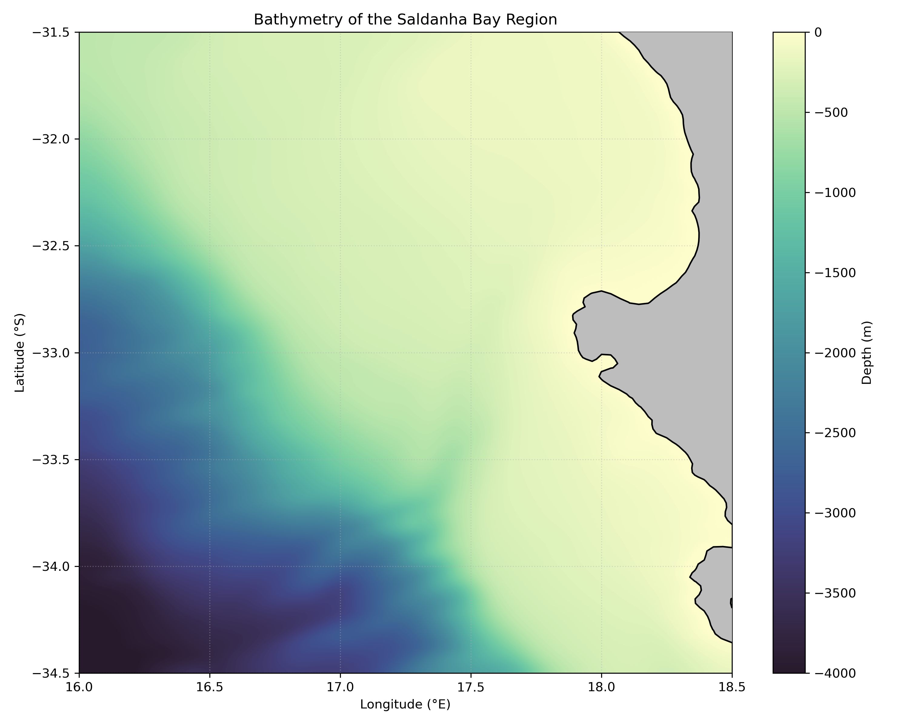Figure 1: Regional bathymetry (Depth, m) of the Saldanha Bay region. The map shows a clear coast–offshore depth gradient, with shallow waters along the nearshore zone transitioning to progressively deeper waters offshore, reaching abyssal depths toward the southwestern extent of the domain. Land areas are masked in grey, and the colour scale represents depth in metres, with lighter shades indicating shallower regions and darker shades indicating deeper areas

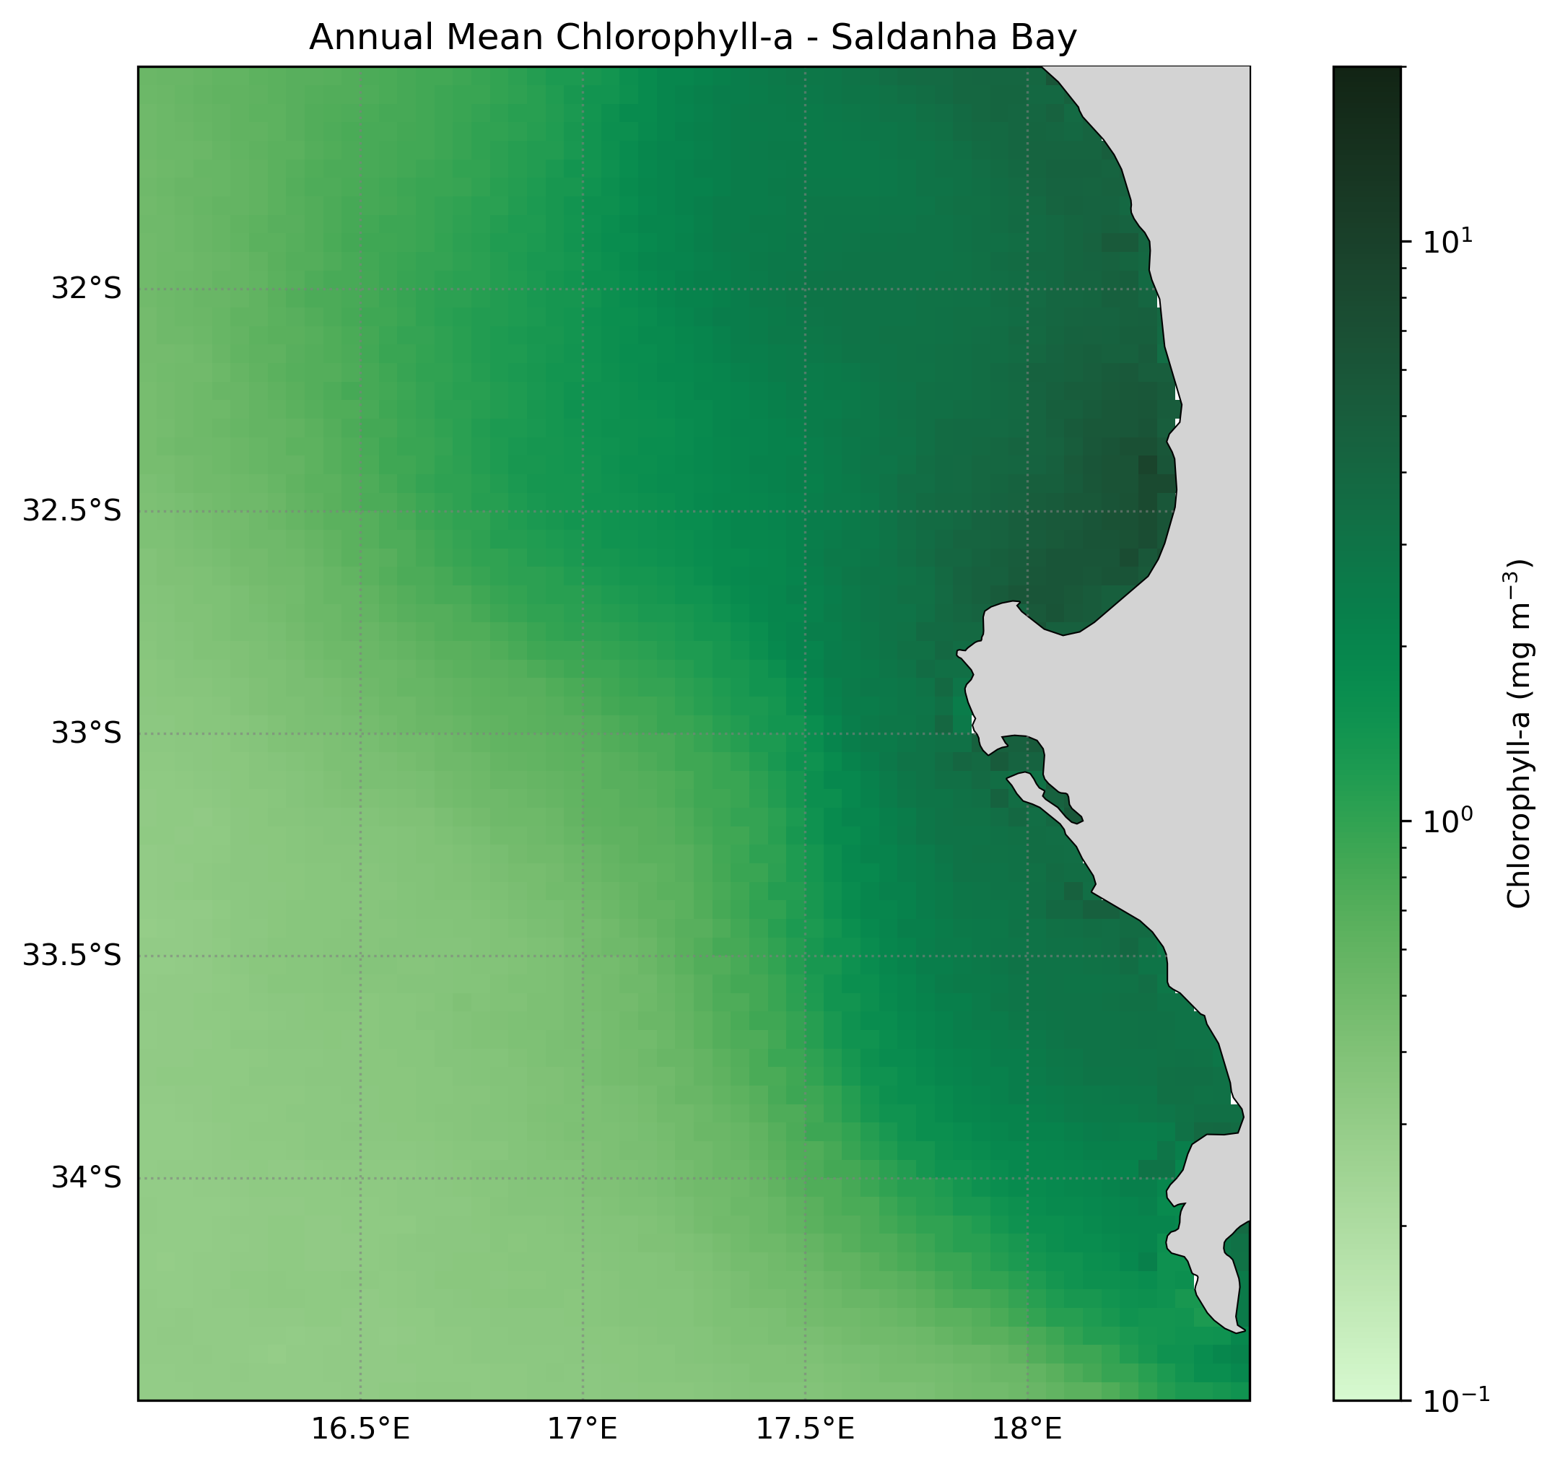
Figure 2. Mean annual chlorophyll-a concentration (mg m⁻³) in the Saldanha Bay region derived from satellite observations. The map shows a pronounced nearshore–offshore gradient, with elevated chlorophyll concentrations along the coastal zone and progressively lower values offshore, reflecting the influence of coastal productivity and upwelling. Land areas are masked in grey, and the colour scale is shown on a logarithmic scale.

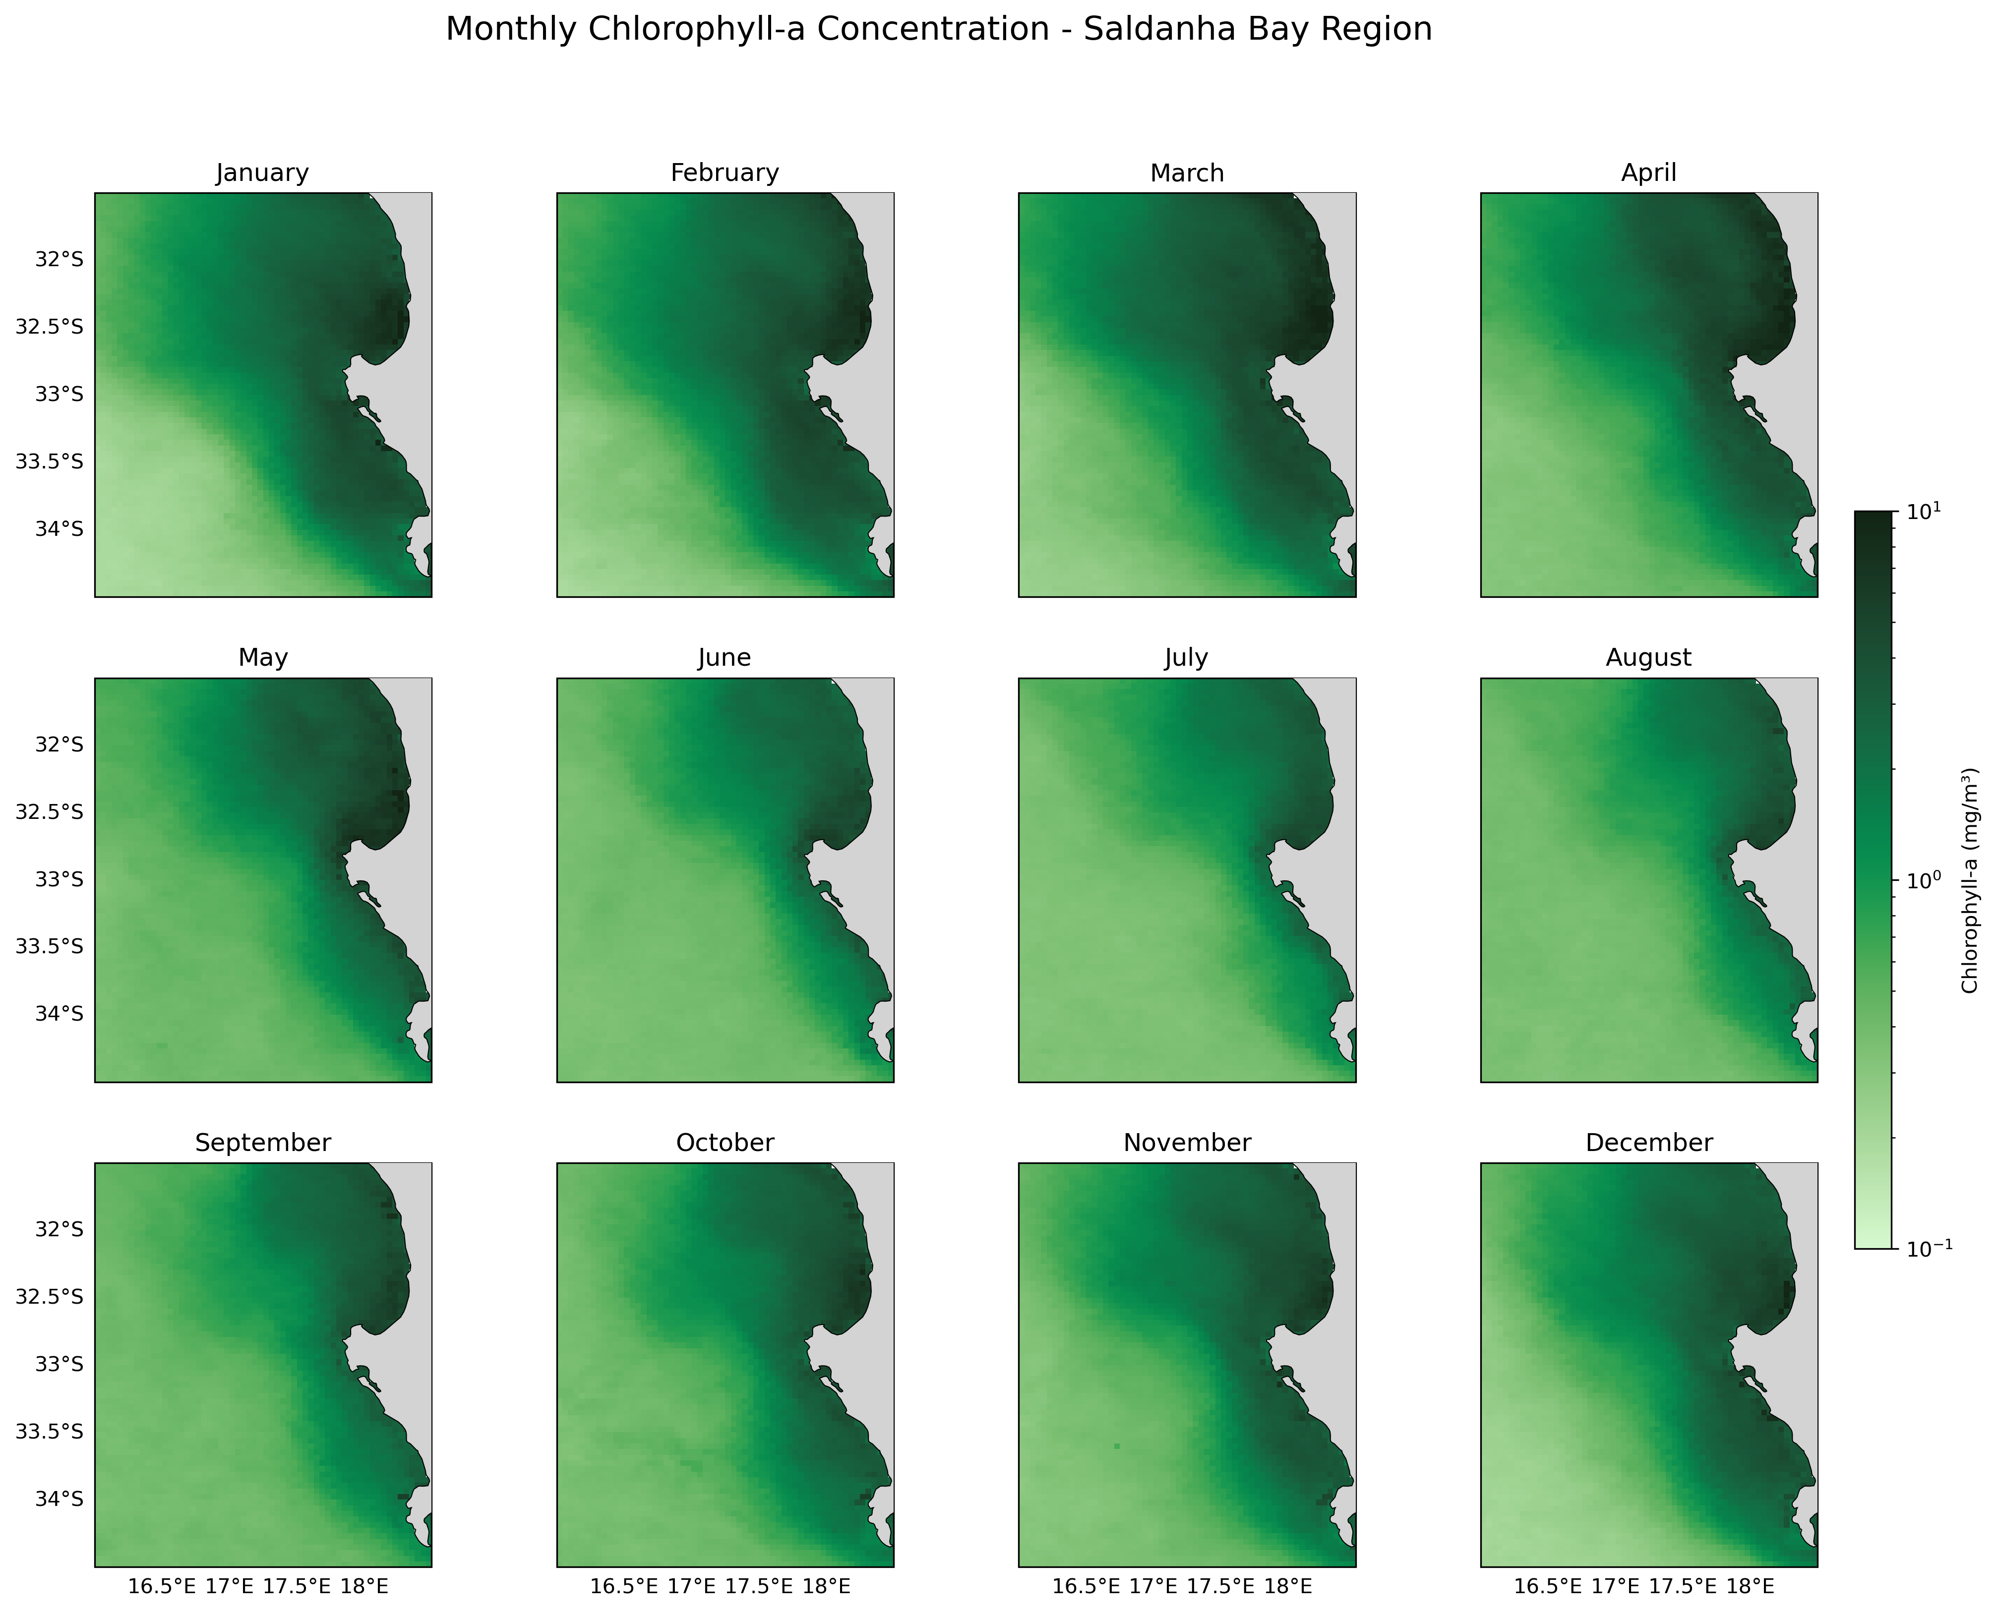
Figure 3: Monthly Chlorophyll-a Concentration in Saldanha Bay. The figure illustrates the seasonal variability of phytoplankton biomass in the region. Each panel shows the spatial distribution of chlorophyll-a (mg m⁻³) for a given month, derived from satellite ocean colour observations. Colours indicate chlorophyll concentration on a logarithmic scale, with darker green representing higher concentrations. Higher concentrations are generally observed near the coast, with clear seasonal variability throughout the year.
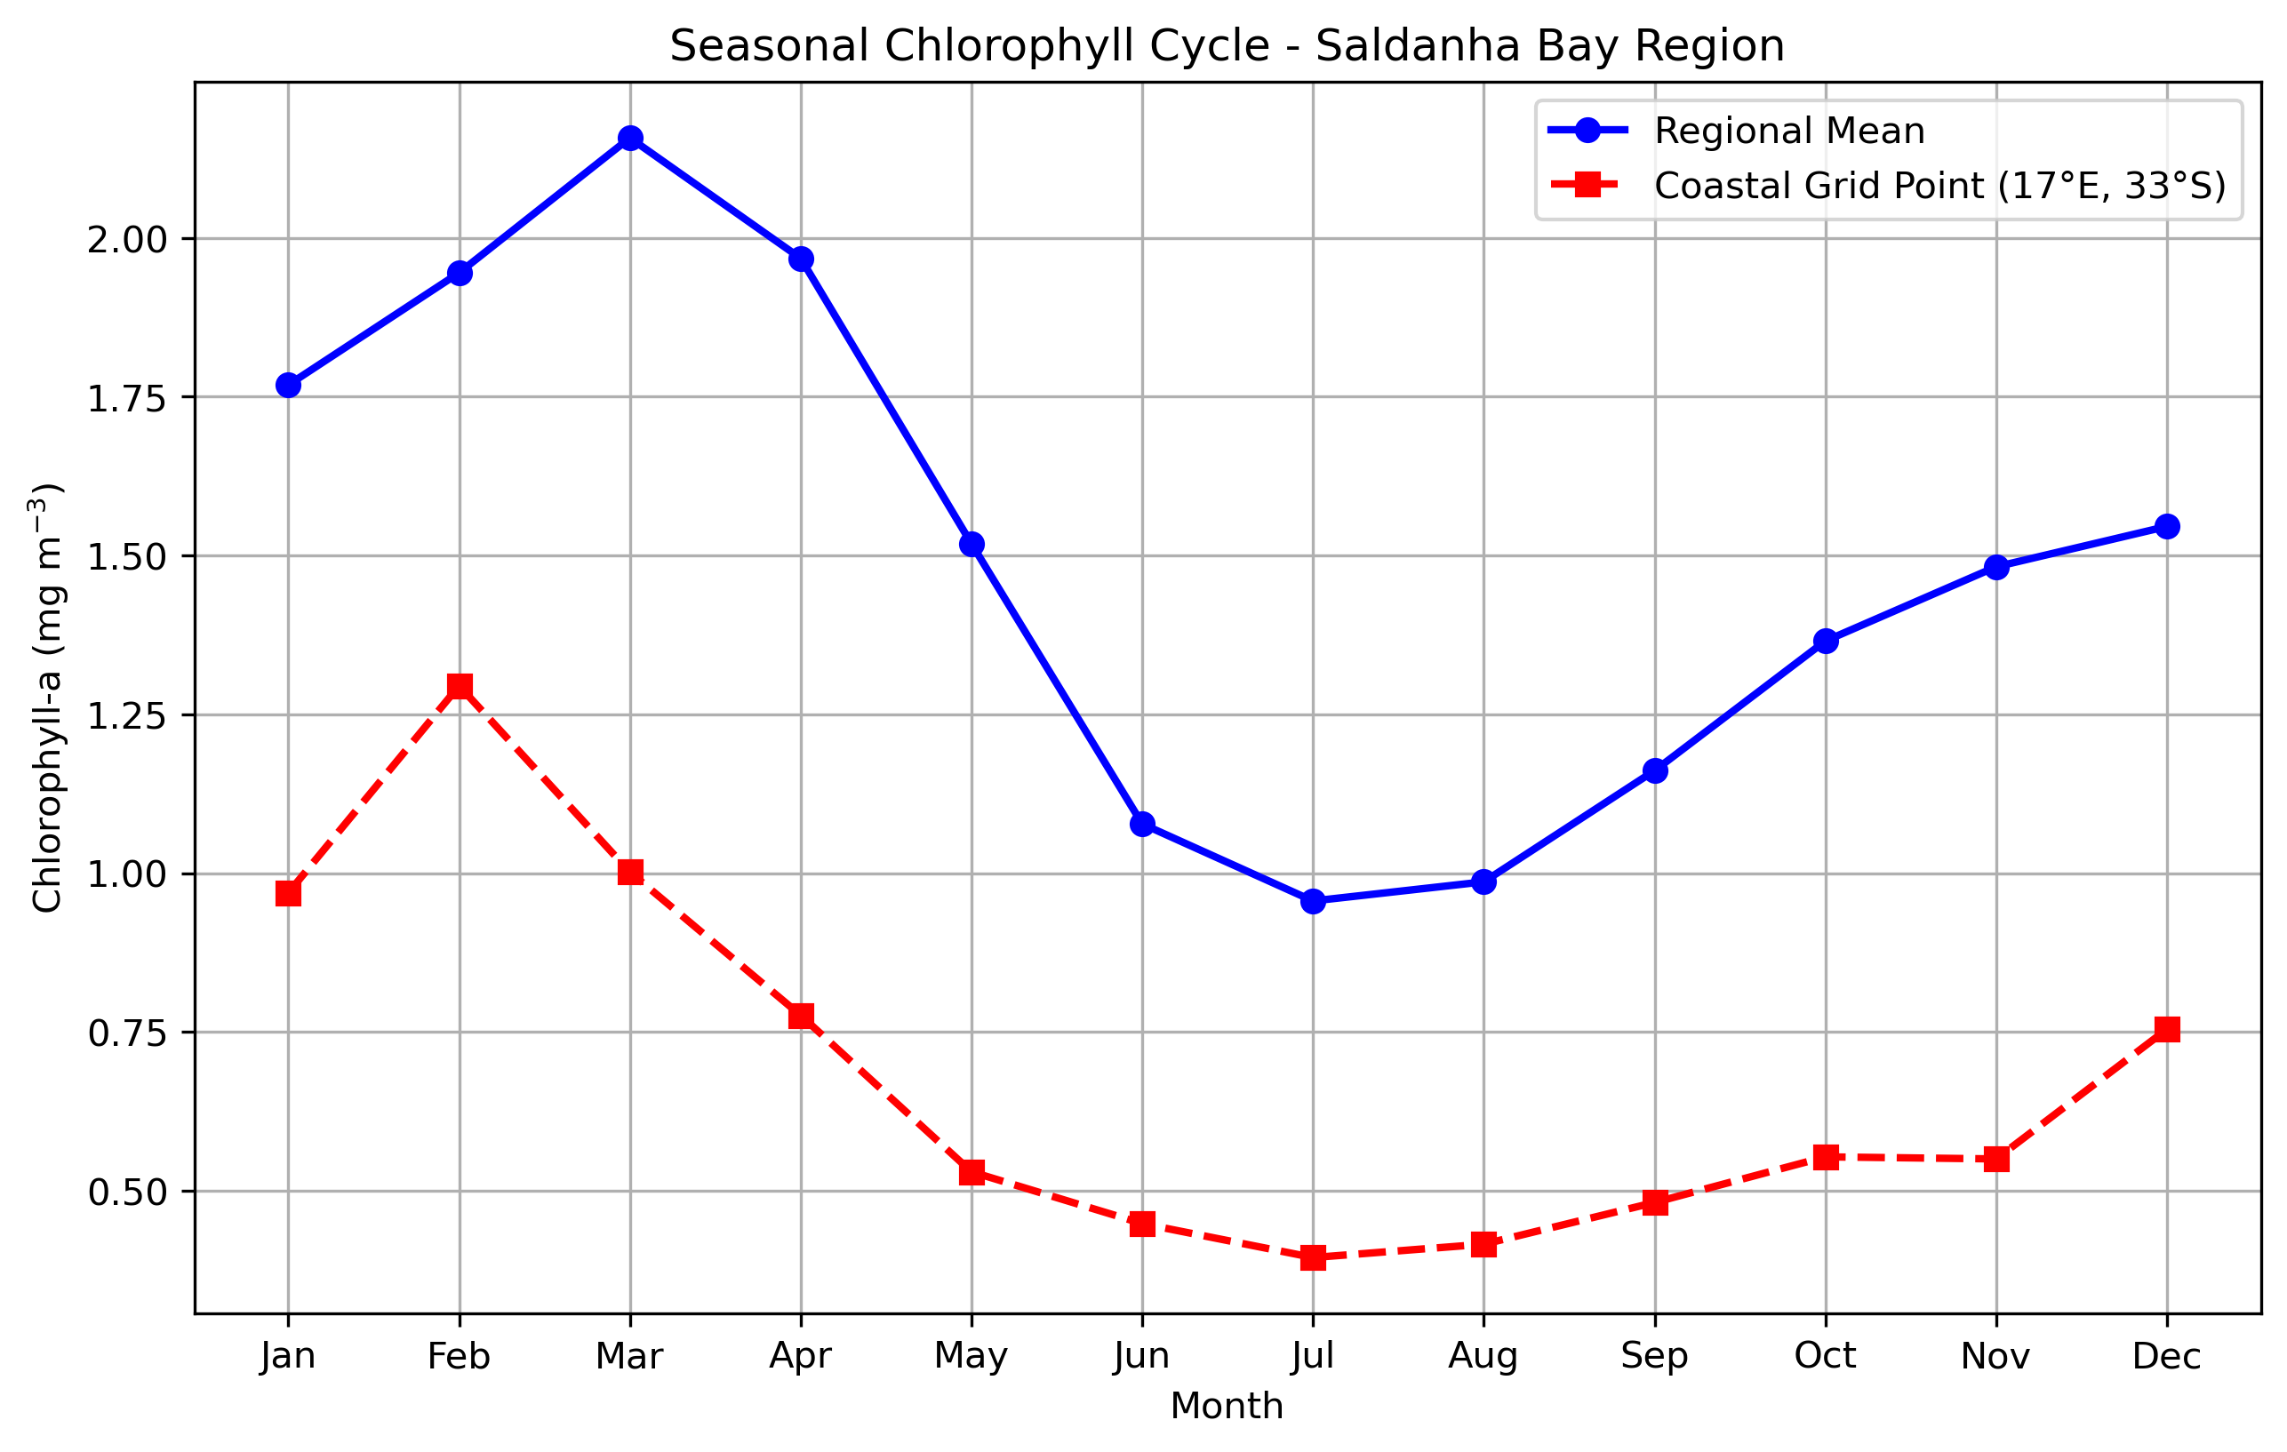Figure 4: Time series of monthly chlorophyll-a concentration (mg m⁻³) showing the mean seasonal cycle for the Saldanha Bay region compared with a selected coastal grid point. Both time series display a clear seasonal pattern, with chlorophyll levels increasing from January, reaching a peak in late summer (February–March), followed by a steady decline towards winter (June–August). The regional mean remains consistently higher than the coastal point, although both follow similar seasonal patterns.

- A disclaimer about your use of AI.

Artificial Intelligence (AI) tools were used in a limited and supportive capacity during the preparation of this assignment. Specifically, an AI language model (Microsoft Copilot) was used to assist with resolving coding errors, understanding technical concepts, and improving the structure of Python-based data analysis workflows.
The AI was used to assist with code development, debugging, visualisation techniques, and general problem-solving related to data processing and plotting. All conceptual understanding, methodological decisions, interpretation of results, and final implementation choices were made by the author/s.

Examples of prompts used include:
- “How do we make the file paths in the notebook work across all computers without the code breaking”
- “How do I compute an annual mean using xarray?”
- “How can I correctly structure my code for plotting an annual mean chlorophyll map?”
- “The map is inverted and hence the slicing is wrong. How do I fix the orientation?”
- “The bathymetry figure looks pixelated. How can I smooth the ocean while keeping the coastline clean?”
- “How do I mask land, so it appears grey and does not blend with shallow ocean depths?”
- “How to correctly structure my code to create 12 faceted maps to represent the seasonal variability of chlorophyll-a and ensuring that the coastline is clearly defined for accurate spatial interpretation”.
- “Why is there a break in my chlorophyll time series and how do I fix it”

References

- Bograd, S. J., et al. (2023). Climate change impacts on Eastern Boundary Upwelling Systems. Annual Review of Marine Science, 15, 303–328. [repository...y.noaa.gov]
- Bordbar, M. H., et al. (2021). The Relation of Wind-Driven Coastal and Offshore Upwelling in the Benguela Upwelling System. Journal of Physical Oceanography. [journals.ametsoc.org]
- Lamont, T., Barlow, R. G., & Brewin, R. J. W. (2019). Long-term trends in phytoplankton chlorophyll a and Size Structure in the Benguela Upwelling System. JGR Oceans, 124, 1170–1195. [agupubs.on....wiley.com]
- Monteiro, P.M.S and Largier, J.L. (1998). Thermal stratification in Saldanha Bay (South Africa) and subtidal, density-driven exchange with the coastal waters of the Benguela Upwelling System. Elsevier: Estuarine, Coastal and Shelf Science
- Salama, A. T., et al. (2025). A coupled physical-biogeochemical modeling approach to investigate the dynamics of the Benguela Upwelling System. Frontiers in Marine Science. [frontiersin.org]
- Wasmund, N., et al. (2016). Phytoplankton stimulation in frontal regions of Benguela upwelling filaments by internal factors. Frontiers in Marine Science. [eprints.soton.ac.uk]
- van Oostende, M., et al. (2022). Correction of inter-mission inconsistencies in merged ocean colour satellite data. Frontiers in Remote Sensing. [frontiersin.org]

